**Scenario #1:** Fill the form and show the list of cars

**GIven:** the form is visible

**And:** I insert the pick-up and drop-off dates

**When:** I click in the ‘Search’ button

**Then:** It should appears a list of cars for me

**Scenario #2:** Select a vehicle to rent

**GIven:** I provide the form

**And:** the list of the cars are visible

**And:** choose a car to rent

**When:** I click in the ‘Rent’ button

**Then:** should show a modal with all the informations like company, price per day, location, license plate, and the pick-up and drop-off dates

**Scenario #3:** Fill the summary form

**GIven:** I’m in the detail’s screen

**And:** I click in the ‘Rent’ button

**And:** show me the summary form to fill

**And:** fill all the inputs like, name, last name, card number and email

**When:** I click in the ‘Rent’ button

**Then:** should be able show a modal with all the informations like company, price per day, location, license plate, and the pick-up and drop-off dates

**Evidences**

**#1**

**Description:** The inputs Country and City should not come filled.

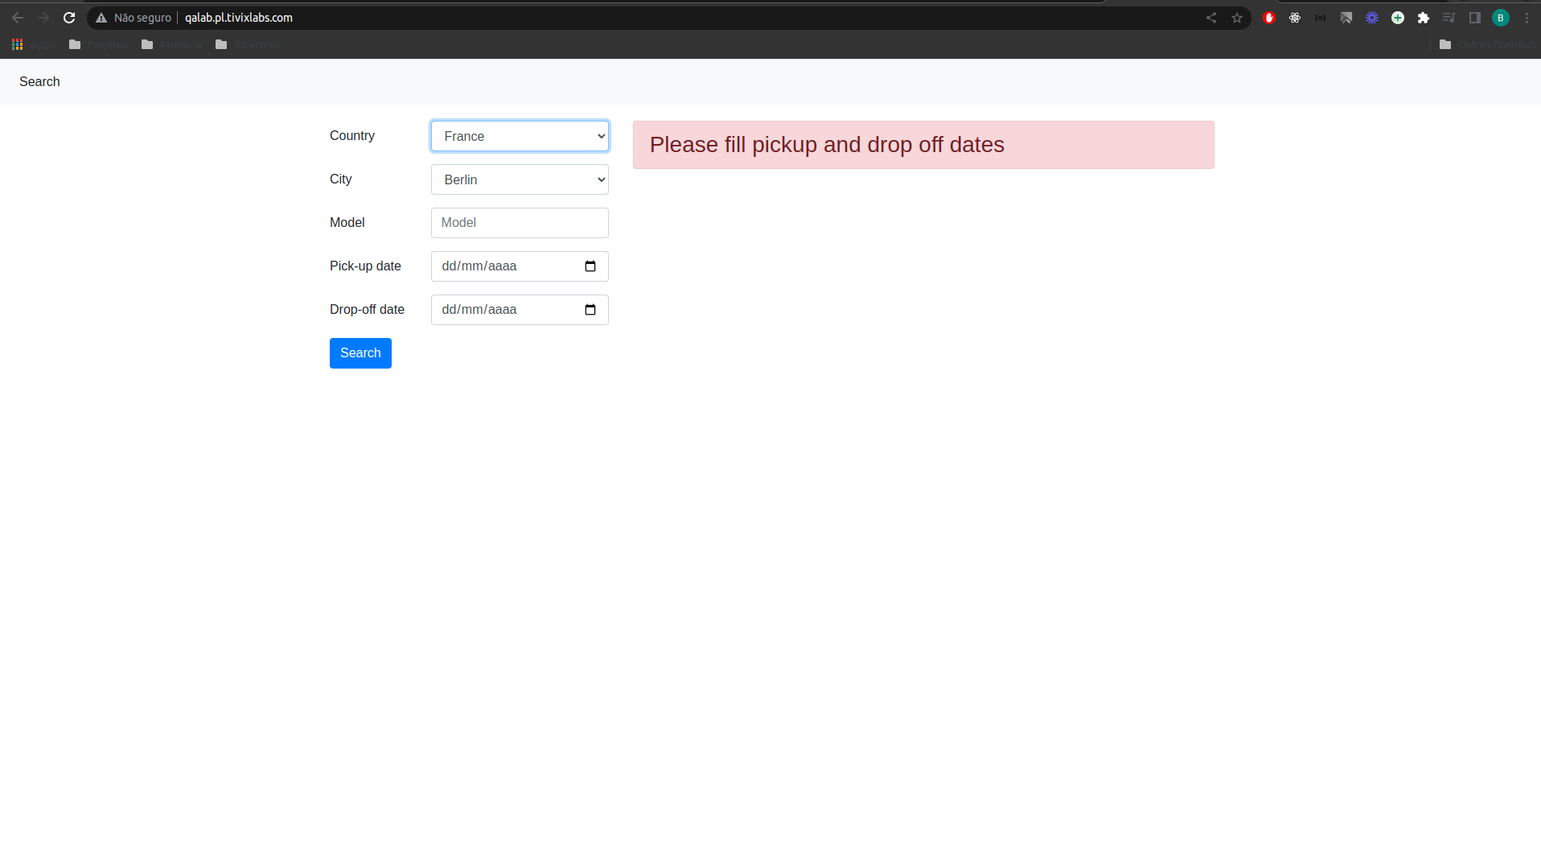

**#2**

**Description:** The input ‘City’ should be enabled only before the country is selected.



**#3**

**Description:** The Country ‘Germainy’ was written wrong, the right is ‘Germany’

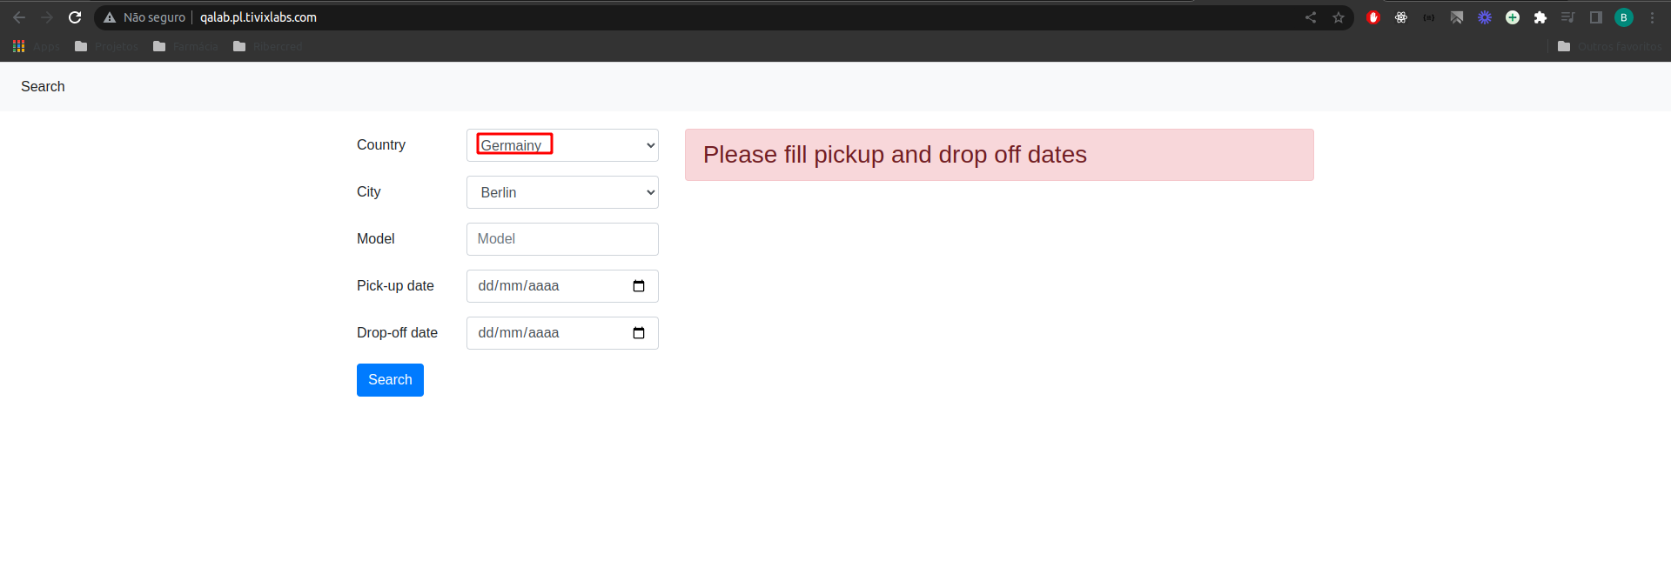

**#4**

**Description:** In the pick-up input date it’s allowing to put a date that already passed and then it’s searching for the cars.

https://www.loom.com/share/a6e3efceec9d4a54b1dede8f6086b6db

**#5**

**Description:** The model filter it doesn’t working

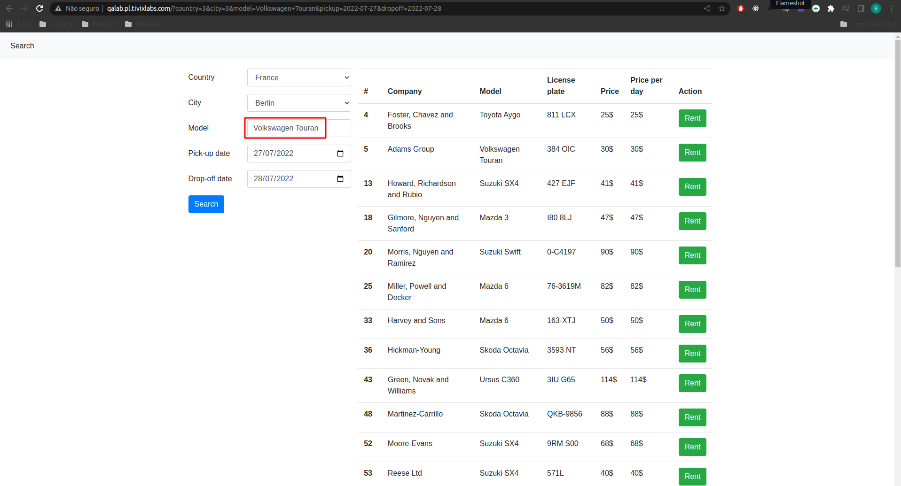

**#6**

**Description:** In the end of the flow after fill all the fields, I receive this error

